1. Create an git repository
   1. Create a repository in github without initializing the readme file https://github.wdf.sap.corp/refapps/espmv2.0
   2. Create a local folder in C:\users\<ino>\git\<folder>
   3. Open Git Command prompt in the above folder and run the below commands - git init
   4. echo # espmv2.0 >> README.md
   5. git add README.md
   6. git commit -m "first commit"
   7. git remote add origin https://github.wdf.sap.corp/refapps/espmv2.0.git
   8. git push -u origin master

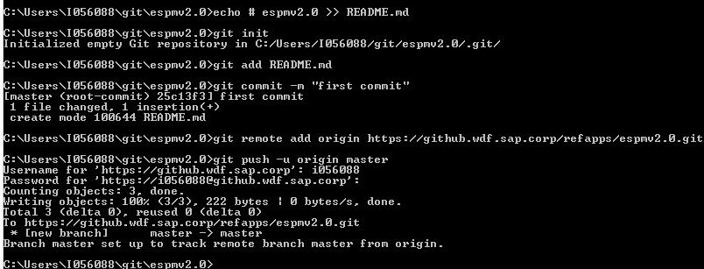

1. Create an orphan branch
   1. git checkout --orphan config/services



* 1. git rm -rf .



* 1. Create the following directories.
     1. production-services -> build-service
     2. production-services -> hcp-deploy-service

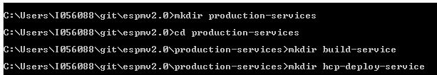

* 1. Create a config.yml file in build-service directory with the below content using your favorite text editor

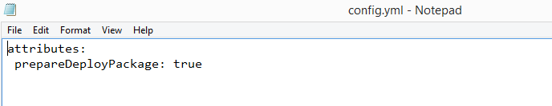

* 1. Create a config.yml file in hcp-deploy-service directory with the below content using your favorite text editor

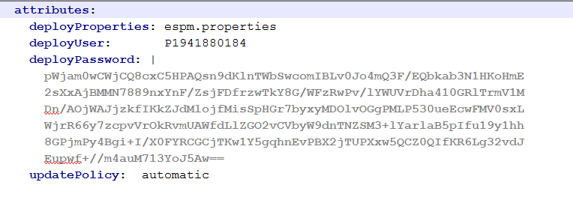

Note –

deployUser – this will be the HCP user in your account.

Deploy Password – this will be password crypt of the deployUser password. <https://github.wdf.sap.corp/ci-connect/ci-connect/blob/master/docs/customProcess/PasswordCrypt.md>

For Windows platform, using gitbash, we can create the password crypt with the following commands

* Download the publicKey.pem file for hcp deploy service from <https://github.wdf.sap.corp/raw/production-services/hcp-deploy-service/config/services/ci-connect/service-definition/publicKey.pem> and place it in your C:\Users\<ino> directory
* Open gitbash, and key in the below command

echo '<full project name>:<password>' |openssl rsautl -encrypt -pubin -inkey <keyFile> | openssl base64 -e

full project name – is your github repository name

password – is the deployUser password

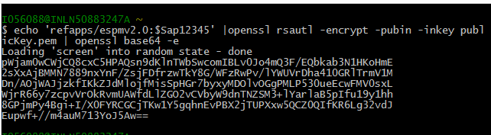

* 1. Add the config.yml file to the git repository

git add production-services\build-service\config.hml

git add production-services\hcp-deploy-service\config.yml



* 1. Commit the changes

git commit -m initial

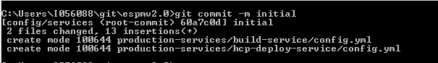

* 1. Push the changes to the git

git push origin HEAD:refs/heads/config/services

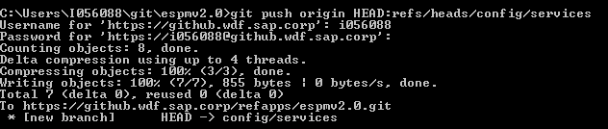

1. Checkout the master branch



1. Create espm.properties file as shown in the working directory using your favorite text editor

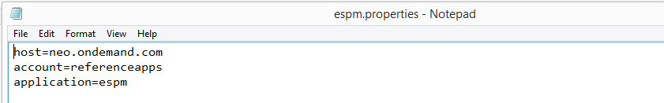

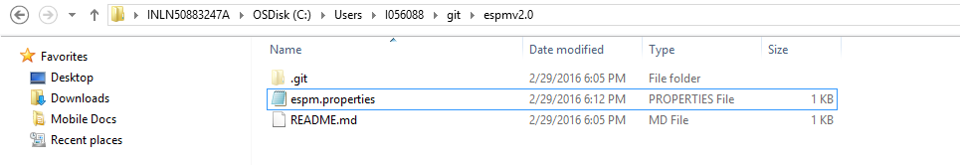

1. Add the espm.properties file to the git repo

git add espm.properties

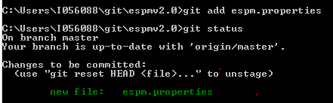

1. git commit -m espm.properties

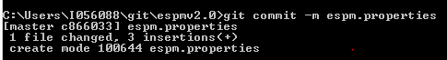

1. push the changes to the git remote repository

git push -u origin master

